09 September 2025

Visualizing African Societies

Gender Disparities in Adolescent HIV Incidence in Africa (2018)

1. **Objective**

To compare HIV incidence rates among young women and young men (ages 10–19) across African countries in 2018, highlighting gender disparities using a bivariate visualization.

1. **Graphic**

A scatterplot compares female HIV incidence rates (y-axis) and male HIV incidence rates (x-axis) among young people (ages 10–19) across African countries in 2018. Each point represents a country, coloured by UNICEF region. A 45° dashed reference line is included: points above the line indicate higher female incidence relative to male incidence, while points on or below the line indicate parity or higher male incidence.

*Figure 1. Scatterplot of female vs male HIV incidence rates by country*

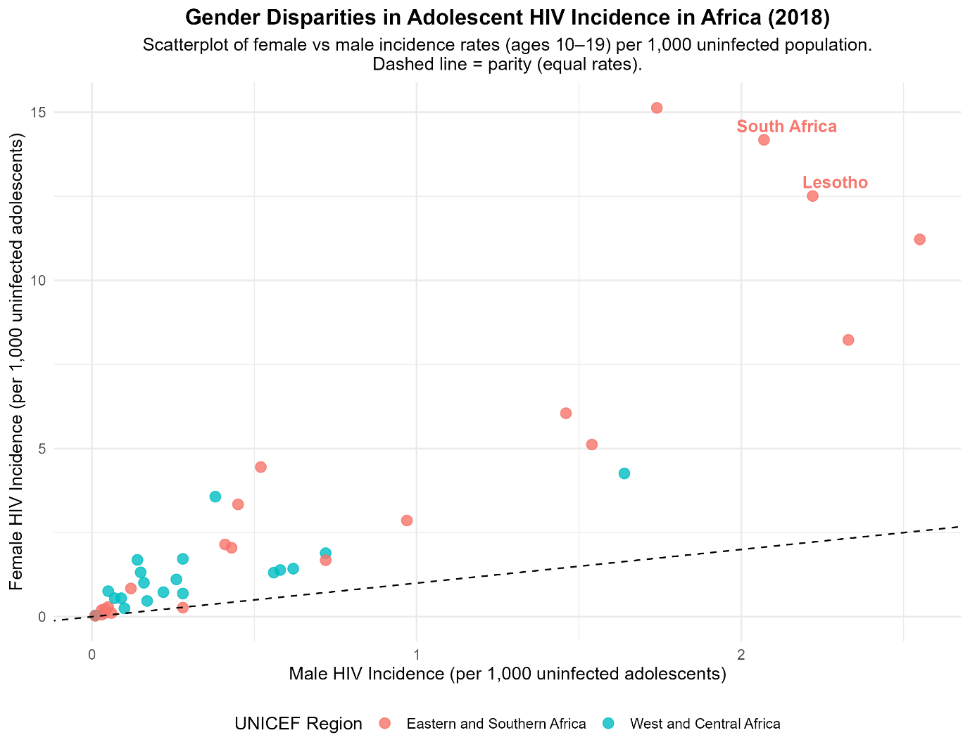

*Scatterplot of female vs male HIV incidence rates by country, coloured by UNICEF region. The dashed line marks parity; countries above the line show higher incidence among adolescent girls.*

1. **Narrative**

The scatterplot demonstrates HIV incidence disparities among adolescents (ages 10–19) in Africa in 2018. Nearly all countries fall above the 45° line, showing that adolescent girls are consistently more affected by HIV than boys of the same age group. The gender gap is most pronounced in Eastern and Southern Africa, where several countries exhibit very high female incidence rates compared to male rates. In contrast, some countries in West and Central Africa are positioned closer to the equality line, indicating smaller gender gaps. This visualization therefore highlights a widespread pattern of gender inequality in HIV burden among African adolescents, with regional variation in the severity of disparity.

Countries such as South Africa and Lesotho illustrate some of the largest disparities, with adolescent girls showing markedly higher incidence rates compared to boys. Highlighting these outliers reinforces the overall finding that female incidence rates consistently exceed male rates across Africa.

1. **Code**

# Load required libraries

library(ggplot2)

library(dplyr)

library(readr)

library(tidyr)

library(janitor)

library(ggrepel)

# Import dataset

data <- read_csv("Jan 2021 Data - Viz5 Gender Inequality and HIVAIDS.csv") %>%

clean_names()

# Filter for 2018, Age 10-19

data_2018 <- data %>%

filter(year == 2018, age == "Age 10-19") %>%

select(

country,

region = unicef_region,

sex,

incidence_rate = estimated_incidence_rate_of_new_hiv_infection_per_1_000_uninfected_population

)

# Pivot wide: Female vs Male incidence

data_2018_wide <- data_2018 %>%

pivot_wider(names_from = sex, values_from = incidence_rate) %>%

rename(FemaleIncidence = Female, MaleIncidence = Male)

# Identify countries to label (South Africa and Lesotho)

label_countries <- c("South Africa", "Lesotho")

# Scatterplot with enhancements

ggplot(data_2018_wide, aes(x = MaleIncidence, y = FemaleIncidence, color = region)) +

geom_point(size = 3, alpha = 0.8) +

geom_abline(slope = 1, intercept = 0, linetype = "dashed") +

geom_text_repel(

data = subset(data_2018_wide, country %in% label_countries),

aes(label = country),

size = 4,

fontface = "bold",

box.padding = 0.3,

point.padding = 0.2,

show.legend = FALSE

) +

labs(

title = "Gender Disparities in Adolescent HIV Incidence in Africa (2018)",

subtitle = "Scatterplot of female vs male incidence rates (ages 10–19) per 1,000 uninfected population.\nDashed line = parity (equal rates).",

x = "Male HIV Incidence (per 1,000 uninfected adolescents)",

y = "Female HIV Incidence (per 1,000 uninfected adolescents)",

color = "UNICEF Region"

) +

theme_minimal(base_size = 12) +

theme(

plot.title = element_text(hjust = 0.5, face = "bold"),

plot.subtitle = element_text(hjust = 0.5),

legend.position = "bottom"

)

# Save plot

ggsave("HIV_gender_disparities_scatterplot_enhanced_2018.png", width = 9, height = 7)